| **The Coversheet Creating Effective Information system (Assignment 2)** | |
| --- | --- |
| Student Name  (unless anonymised) | Enyi Onyinye grace |
| Student Number  (as shown on student ID card): | 220188148 |
| Word Count: | 2000 + 10% = 2194 |
| Attempt Number: | 1 |
| Date of Submission: | 11/06/2025 |

|  |  |
| --- | --- |
| I have read and understood the [Academic Misconduct statement](https://blog.yorksj.ac.uk/assessment/coversheet-statements/). | Tick to confirm |
| I have read and understood the [Generative Artificial Intelligence use statement](https://blog.yorksj.ac.uk/assessment/coversheet-statements/). | Tick to confirm |
| I am satisfied that I have met the Learning Outcomes of this assignment  (please check the Assignment Brief if you are unsure) | **​​​** Met |

|  |
| --- |
| **Self-Assessment** – If there are particular aspects of your assignment on which you would like feedback, please indicate below.  Optional for students |
| ***Suggested prompt questions-***  *How have you developed or progressed your learning in this work?*  *What do you feel is the strongest part of this submission?*  *What feedback would you give yourself?*  *What part(s) of this assignment are you still unsure about?* |
|  |

# **Creating Effective Information Systems**

# **Final Project Report – Assessment 2 PART 1**

**Contents**

**Creating Effective Information Systems** 1

**Final Project Report – Assessment 2 PART 1** 1

**Executive Summary** 3

**1. Introduction** 4

**2. Business Context and Problem** 4

**3. Proposed Information System** 4

**4. UML Design** 5

**5. Use Case Diagrams and Commentary** 6

**6. Evaluation of the System** 6

**7. AI Usage** 7

**PART 2** 7

**8. Reflection on Learning** 7

**9. Conclusion** 8

**10. References** 10

**11. Appendices** 11

**Appendix A – UML Entity-Relationship Diagram** 11

**Appendix B – Customer Use Case Diagram** 12

**Appendix C – Employee Use Case Diagram** 12

**Appendix D – Manager Use Case Diagram** 13

**Appendix E – Screenshots of Forms, Queries, and Reports** 14

# **Executive Summary**

This report presents the development, implementation, and evaluation of a role-based business information system tailored to a wire manufacturing and distribution company operating across multiple Nigerian branches. The system was developed using Microsoft Access and successfully integrates customer ordering, inventory tracking, and role-specific access for customers, employees, and managers. It supports the tracking of copper wire sourced from local Nigerian suppliers and coating materials imported from Turkey, linking them through semi-finished production into final wire products ready for sale.

The login system authenticates users based on role, directing them to relevant forms and reports while applying access controls through conditional logic and validation rules. The system includes dynamic navigation menus, user-specific dashboards, and automated reporting features, improving both efficiency and usability.

However, some limitations were identified during testing. While the LoginTbl is currently linked to the CustomerTbl via CustomerID, this method does not automatically carry the user’s identity through the session. Customers must still manually input their ID to view their order history. Planned improvements include implementing session-based filtering using global variables, linking LoginTbl to employee and manager records for better role recognition, adding an activity log for transparency, and enhancing reports with branding and summaries.

Overall, the system provides a solid and scalable foundation. It meets its core functional requirements and offers multiple pathways for further refinement. This report documents the system’s architecture, testing outcomes, and critical reflection on both achievements and future improvements.

# **1. Introduction**

This report outlines the design and evaluation of a role-based business information system developed in Microsoft Access for a wire manufacturing and distribution company in Nigeria. The company sources copper wire locally and imports coating materials from Turkey to produce finished products distributed across multiple branches.

Previously, operations were managed through spreadsheets, leading to data inconsistency and limited control. The new system introduces secure login authentication and role-specific dashboards for customers, employees, and managers, supporting inventory tracking, order management, and reporting through structured tables, queries, and form logic.

While functional and aligned with business needs, areas for improvement include better session-based filtering for customers, linking login records to employees and managers, implementing an activity log, and enhancing report presentation. This report covers the system’s context, architecture, testing outcomes, and future development goals.

# **2. Business Context and Problem**

The company operates in the electric wire manufacturing industry with a nationwide supply chain. It sources coating materials from Turkey and procures copper wire locally from Nigerian suppliers. These materials are processed into semi-finished wires at the Benin factory, then converted into finished products for distribution through branches across Nigeria.

Before this project, the company used separate spreadsheets for customer orders, inventory tracking, and staff operations, leading to data duplication, inconsistent stock records, and operational bottlenecks (Mecalux, 2016). The lack of a centralized system prevented managers from tracing product movements from procurement to delivery. Employees had unrestricted access to critical data, increasing the risk of errors. Additionally, manual reporting slowed decision-making due to time-consuming data collation.

The company needed a system to unify records, implement role-based access, and support traceability from material sourcing to sales. The goal was to improve operational efficiency, ensure data security, and enhance business performance visibility for all stakeholders.

# **3. Proposed Information System**

To address the business challenges, a comprehensive information system was developed using Microsoft Access. This system integrates customer data, product inventory, raw material sourcing, semi-finished and finished product tracking, and branch-level reporting. It features a login authentication mechanism linked to the **LoginTbl**, where each user is assigned a role (customer, employee, or manager). The user interface adjusts dynamically based on role permissions, utilizing **DLookup** functions and form control logic.

Raw materials are tracked through two primary tables: **CopperWireTbl** and **CoatingMaterialTbl**. The company records copper purchases from local Nigerian suppliers, including order dates, delivery dates, quantities, and prices. Imports of coating materials from Turkey are logged, detailing material type, quality, weight, and cost. These materials are connected to the **SemiRawMaterialTbl**, which tracks the production of semi-finished wires, documenting quantities, sizes, colours, and the combination of copper and coating batches used.

The **FinishedProductTbl** captures completed wire products ready for sale, including model, name, price, and associated semi-finished materials. Orders are recorded in the **OrderInventoryTbl**, linking customers and branches, while individual items ordered are stored in the **OrderFinishedProductsTbl**, maintaining data integrity and enabling real-time stock deductions.

Customers use the system to place and review orders, employees can view and update product records, record production outputs, and assist customers. Managers have full access to generate stock, sales, and customer reports, filtered by product, date, or branch. The system maintains referential integrity through primary and foreign key constraints and improves usability with structured forms, visual indicators, and validation rules (PATRA, 2024).

# **4. UML Design**

The architecture of the system is illustrated in the UML Entity-Relationship Diagram in Appendix A. The LoginTbl is linked to the CustomerTbl through CustomerID, although CustomerID is not yet used to retrieve customer identity. Its primary function is user authentication and access control via the ustatus field, classifying users as customers, employees, or managers. Although not involved in relational joins, it plays a key role in directing users to appropriate interfaces during login.

The CustomerTbl stores customer details and connects to the OrderInventoryTbl, recording transaction history. This links to the OrderFinishedProductsTbl, capturing individual items within each order. On the operational side, CopperWireTbl and CoatingMaterialTbl track raw material procurement from local and international suppliers. These materials are combined in the SemiRawMaterialTbl, recording semi-finished wire production and bridging raw materials and finished products.

The FinishedProductTbl links to SemiRawMaterialTbl, maintaining product traceability throughout manufacturing. Branch information is managed in the BranchTbl, while employee details are stored in the EmployeeTbl, optionally linked to the DepartmentTbl. This structured, normalized design ensures efficient querying, robust data integrity, and a logical flow of information across the system (Lewis and Sauro, 2021).

# **5. Use Case Diagrams and Commentary**

Use case diagrams are presented in **Appendices B, C, and D** for customers, employees, and managers respectively. These diagrams demonstrate how each user role interacts with the system.

Customers begin by registering and logging in, **Example Username Graceenyi, Upassword 12345678.** They can then browse available finished products, place new orders, review past transactions, and print invoices. They do not have access to internal stock data or customer records.

Employees use the system to update product quantities to login into the system they use their login details **Example Username Stasha, Upassword 1872**, input semi-finished production data, assist customers with queries, and manage orders. Their access is restricted to operational functions and does not include managerial reporting tools.

Managers have complete access with their login details **Example Username Promise, Upassword Promise1234**. They can view sales performance across branches, generate analytics on customer orders and stock levels, manage employee records, and review inventory flows from raw materials to final sale. These diagrams collectively illustrate the flow of actions and access boundaries enforced by the system’s architecture.

# **6. Evaluation of the System**

Testing confirmed that the system met its primary objectives. Upon login, users were directed to their dashboards, with access controlled by the ustatus field in the LoginTbl. Customers could place orders, view finished products, access their order history, and update their details. Employees managed product records, monitored pending orders, placed orders for customers, and updated delivery statuses. Managers accessed detailed reports, providing insights into inventory levels, sales performance, and customer activities across all branches. Queries and reports performed accurately, based on the user's role and input parameters. These functionalities supported operational efficiency and allowed the company to streamline processes.

The use of validation rules significantly reduced data entry errors, particularly in order and inventory forms. Forms dynamically adapted to the user's role by hiding or locking unnecessary fields, creating a more streamlined and secure experience. DLookup functions were effectively utilized to personalize the interface by retrieving role-specific details, such as welcome messages with the username and role, without manual input. This contributed to a more intuitive and responsive user experience, especially for users with varying levels of access (PATRA, 2024). **Appendix E** shows the full evaluations of the system with diagrams and screenshots.

However, some limitations were identified during evaluation. Customers must manually select their CustomerID to place orders. While the login process is linked to the CustomerTbl, the system does not retain the user's identity during the session. Future updates will introduce session-based filtering using global variables like TempVars, allowing the system to remember the user and automatically filter data accordingly. The login structure also lacks direct links to employees and managers, so the LoginTbl will be expanded to include EmployeeID and ManagerID, allowing precise user identification across the system, improving accuracy and streamlining processes. The "Search by" textbox currently requires managers to manually type the areas, but an improvement will add a dropdown menu with the available fields. This will make the search process more efficient, allowing managers to easily select the field they want to search by, reducing manual input and errors.

Further enhancements are planned, including the development of an audit trail to log activities such as logins, order placements, and stock changes. A dedicated table (ActivityLogTbl) will be used, with actions captured via VBA to ensure accountability and transparency. Report layouts will also be improved by incorporating consistent branding, headers, and summary footers. Finally, a backup function will be introduced to allow users to create timestamped copies of the database, safeguarding data in the event of system failure, ensuring system reliability and minimizing risk.

# **7. AI Usage**

Artificial Intelligence tools were used in limited, non-critical capacities during the system’s development. Specifically, AI was used to generate random sample data to populate tables for testing relationships and query logic. Additionally, AI image-generation tools were used to create visual examples of finished wire products. These images were included in forms to enhance user experience and provide visual confirmation of selected products.

No AI tools were used to create the system structure, implement logic, generate code, or write this report. All technical and academic work, including form design, access control, queries, reflection, and evaluation, was completed independently in alignment with the learning outcomes of this module.

# **PART 2**

# **8. Reflection on Learning**

The development of this business information system has been both technically and personally enriching. Initially, my database knowledge was basic, focusing on creating tables and running simple queries. I had never built a fully functional system with complex relationships, role-based access control, and real-time data interaction through tailored forms and reports. This project allowed me to bridge the gap between theory and practice and equipped me with essential skills for my future career in digital business systems.

Using Gibbs' Reflective Cycle as a framework (McLeod, 2025), I reflect on the experience. I was tasked with designing a system to track copper and coating materials, manage semi-finished wire production, and control sales and stock across multiple branches. While the business problem was clear, I had to build the technical solution from scratch, including data modelling, relationship building, query creation, form design, and generating parameterized reports. I also implemented access control through **DLookup** to ensure users whether customers, employees, or managers only saw relevant features and data.

As the system evolved, I added features to enhance functionality and usability. I created a dynamic pending order system that updates records across various delivery status forms in real time. Custom forms were designed to respond to user roles, filtering views and hiding sensitive areas. I also integrated dynamic reporting, enabling users to print reports filtered by branch or customer, and added a professional “About Us” form to introduce the company. To implement solutions like DLookup and session-based filtering, I had to research independently and watch tutorials on YouTube on how to write VBA’s, which improved my problem-solving and technical learning process.

Emotionally, I encountered uncertainty at first, especially when my early relationship diagrams became too complex or queries did not return expected results. I struggled with dynamic form behaviour and logic errors, particularly in VBA when managing button actions or showing/hiding elements based on login roles. However, with persistence, I overcame these challenges, and each success increased my confidence. By the time I implemented parameterized reports and completed test sessions with role-based interfaces, I felt a strong sense of achievement.

Evaluating the experience, the most valuable outcome was understanding the relationship between database theory and user experience (Lewis and Sauro, 2021). I realized that designing for people is just as important as designing for data. Adding visual aids like product images, color-coded status labels, and validation prompts made the system more user-friendly. I also gained an appreciation for referential integrity, structured naming, and data validation, which ensured system reliability. Additionally, using AI to generate random data taught me that I do not need to waste time manually inputting random data. Instead, I could focus more on system development, which saved time and increased efficiency.

From an analytical perspective, the skills I developed during this project will contribute significantly to my professional goals. I am now more adept at structuring complex data environments, designing queries that reflect real-world decision-making, and considering access control. I see the value in learning additional tools like Power BI and cloud-based databases to expand on this foundation. Moving forward, I plan to implement session-based filtering with TempVars, create an audit trail to log key activities, and enhance data security with a backup function.

This experience taught me the value of iterative development, the importance of testing, and the role of reflection in personal growth. I am now more confident in my ability to develop information systems that address business problems and am motivated to continue refining the skills I have gained. This reflection confirms that I have met the module’s learning outcomes and am better prepared to contribute meaningfully to technology-driven business environments.

# **9. Conclusion**

The information system developed in this project successfully addresses the company’s operational inefficiencies by centralising data, streamlining workflows, and enforcing secure, role-based access. It replaces outdated spreadsheets with an interactive platform that supports customers, employees, and managers in performing their respective duties. From sourcing copper locally and importing coating materials, to producing, selling, and tracking finished goods, the system supports the full lifecycle of the business.

In addition to improving stock visibility and order processing, it also empowers managers to make informed decisions based on real-time reports and trends. This project demonstrates not only technical proficiency in system development but also a holistic understanding of how information systems solve business problems. The reflective journey highlights the value of experiential learning, critical thinking, and adaptability in navigating technical challenges. The final result is scalable, user-friendly, and business-aligned database solution ready for future enhancements.

# **10. References**

Lewis, J.R. and Sauro, J. (2021). *USABILITY AND USER EXPERIENCE: DESIGN AND EVALUATION*. [online] ResearchGate. Available at: <https://www.researchgate.net/publication/373487143_USABILITY_AND_USER_EXPERIENCE_DESIGN_AND_EVALUATION> [Accessed 9 Jun. 2025].

McLeod, S. (2025). *Gibbs Reflective Cycle*. [online] Simply Psychology. Available at: <https://www.simplypsychology.org/gibbs-reflective-cycle.html> [Accessed 9 Jun. 2025].

Mecalux (2016). *Easy WMS | Warehouse Management System*. [online] Mecalux.co.uk. Available at: <https://www.mecalux.co.uk/software/warehouse-management-system-wms?src=bg¶m1=o&param2=WMS%20%7C%20WMS%20%23HAGAKURE&param3=WMS&param4=c&param5=the%20company%20used%20separate%20spreadsheets%20for%20customer%20orders> [Accessed 9 Jun. 2025].

PATRA, S.K. (2024). *Ensuring Data Integrity in Databases: Primary Keys, Foreign Keys, and Constraints*. [online] Csinfo360.com. Available at: <https://www.csinfo360.com/2024/09/Data-Integrity-Primary-Keys-Foreign-Keys.html> [Accessed 9 Jun. 2025].

# **11. Appendices**

## **Appendix A – UML Entity-Relationship Diagram**

This appendix presents the UML Entity-Relationship Diagram (ERD) for the developed information system. The ERD provides a visual representation of the database structure, showing how different tables (entities) are related to one another through defined relationships. It forms the technical backbone of the system and was used during development to ensure data integrity, consistency, and efficient query design.

The diagram includes key entities such as:

* LoginTbl: Stores user credentials and role information (ustatus). This table is currently linked to the CustomerTbl via CustomerID, enabling identification of customers during login. Future updates will include links to EmployeeID and ManagerID for more complete role tracking.
* CustomerTbl: Holds customer details and is related to the OrderInventoryTbl, which stores transaction records.
* OrderFinishedProductsTbl: Connects customer orders to specific finished wire products selected during the order process.
* CopperWireTbl and CoatingMaterialTbl: Store raw material data, which feed into the SemiRawMaterialTbl to record semi-finished wire production.
* FinishedProductTbl: Contains final wire products for sale and links directly to the SemiRawMaterialTbl for traceability.
* BranchTbl, EmployeeTbl, and DepartmentTbl: Manage organisational data such as staff assignments and branch operations.

The relationships between these tables are governed by primary and foreign keys, ensuring referential integrity throughout the database. The ERD reflects a normalized structure, supporting efficient data storage, simplified querying, and scalable system design.

This diagram served as a reference throughout development and helped guide the logical flow of data from user input to report output.

Copper_wire_material

Produced_semi_raw_material

Coating_raw_material

Copper_wire_ID (PK)

Order_date

Arrival_date

Quantity

Weight_of_copper(kg)

Price_of_copper

Semi_raw_material(PK)

Coating material ID(FK)

Copper_wire_ID(FK)

Production_date

Quantity_produced

Sizes_of_semi_finished_wire

Capacity

Colour_of_material_produce

Coating material ID (PK)

Type of coating material

Quality of the material

Material order_date

Arrival date

Weight of material(kg)

Price of the material

Order_finished_products

Product_types

Finished_products

Order_finished_products_ID(PK)

Product_type(FK)

Order_date

Order_inverntory_Id (FK)

Quanttites_ordered

Product_type(PK)

Finished_product_ID (FK)

Quantities

Price_of_the_product

Finished_product_ID (PK)

Semi_raw_material(FK)

Modal_of_wire

Sizes_of_finished_products

Prices_of_finished_product

Product_name

Colour_of_the_product

Customer_details

Customer_ID (FK)

Firstname

Lastname

Phone_number

Email

Address

States

Registration_date

Order_inverntory_Id (PK)

Branch_ID (FK)

Customer_ID (FK)

Order_inventory

Branch_ID

Branch_ID (PK)

Name_of_branch

Address

Contact_number

State

Manager_name

Login table

Employee_details

Departments

Department_ID (PK)

Name_of_Dept

Employee_ID (PK)

Name

Rank

Branch_ID (FK)

Salary

Hire_date

Department_ID (FK)

UserID (PK)

customeriD (FK)

Username

Uphone

Udate

Ugender

U Username

Upassword

Ustatus

Uage

Authors own (2025)

## **Appendix B – Customer Use Case Diagram**

This use case diagram outlines how a customer interacts with the system after a successful login. Customers are limited to actions that relate to their own transactions. The diagram shows that customers can browse available finished wire products, place orders, view their order history, and print invoices. These actions are designed to provide customers with secure, personalised access to the services they need, without exposing data that belongs to other users. Each use case in the diagram represents a real interaction a customer might perform when using the system.

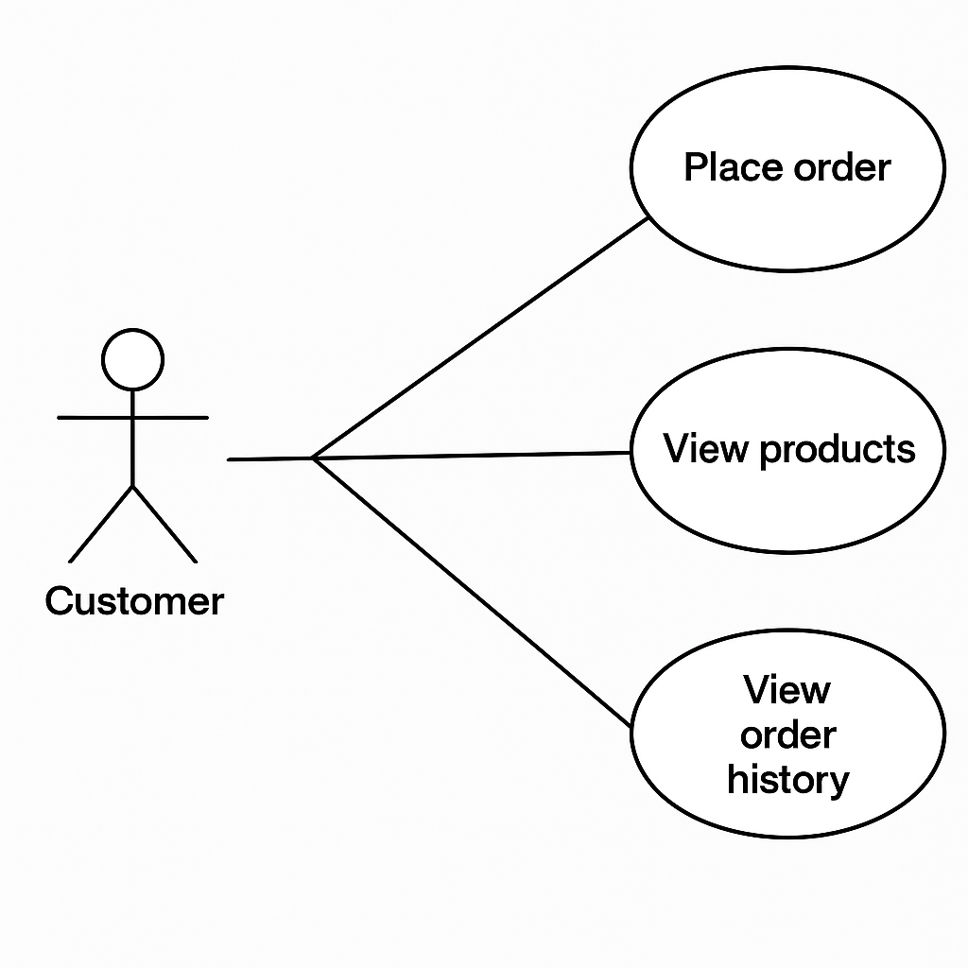

Authors own (2025)

## **Appendix C – Employee Use Case Diagram**

This use case diagram represents the tasks performed by employees who manage inventory and customer orders. Employees have broader access compared to customers and are responsible for updating product stock levels, managing and fulfilling orders, and recording the output of semi-finished products. The diagram shows how employees interact with different parts of the system to carry out operational activities, supporting day-to-day warehouse and order handling tasks. While employees can view and update various records, they do not have access to administrative reports reserved for managers.

Authors own (2025)

## **Appendix D – Manager Use Case Diagram**

This diagram illustrates the role of the manager within the system. Managers have the highest level of access and are responsible for overseeing the entire operation. The diagram shows that managers can view and generate reports, monitor stock across all branches, and manage inventory levels. They can access business intelligence data to track sales performance and ensure operational efficiency. The use cases in this diagram reflect the analytical and supervisory role of managers, supporting strategic decision-making within the organisation.

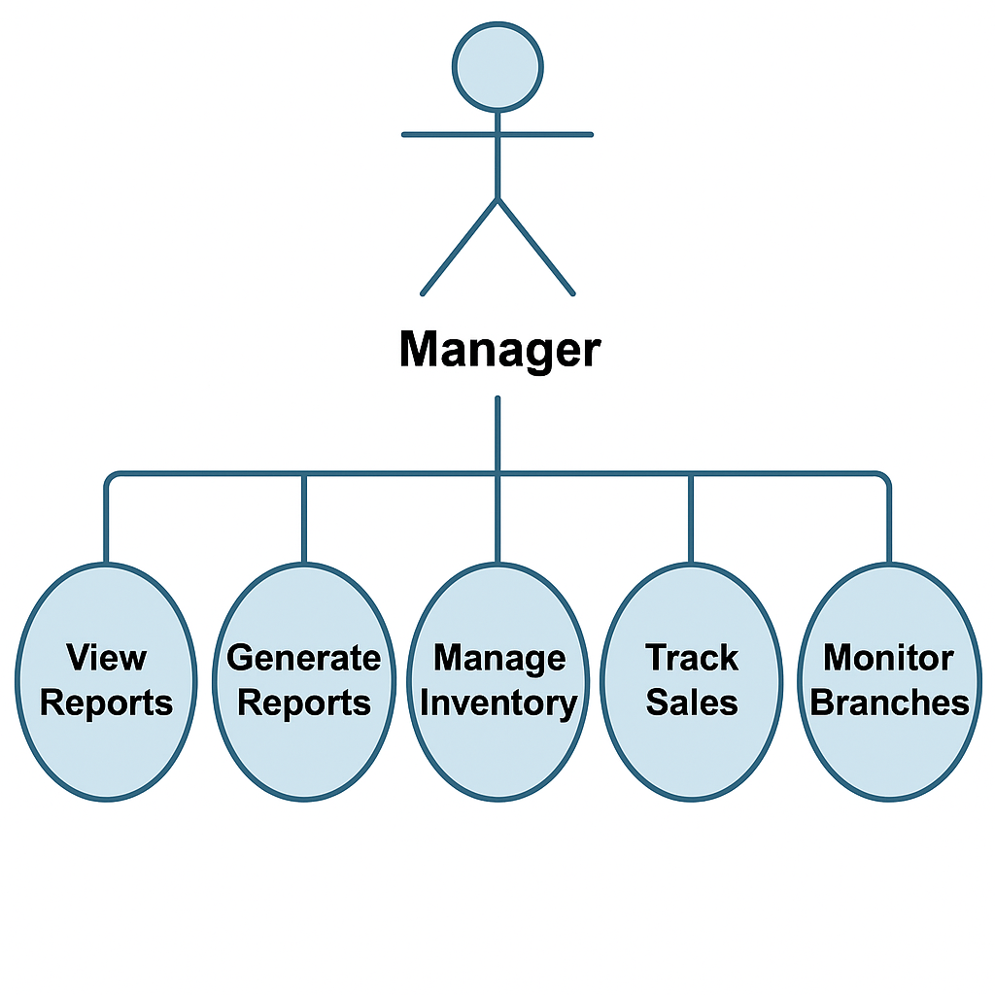

Authors own (2025)

## **Appendix E – Screenshots of Forms, Queries, and Reports**

This appendix contains a collection of screenshots taken from the developed Microsoft Access database system. These visuals demonstrate how key components of the system operate across different user roles, including customer, employee, and manager interfaces.

The screenshots have been included to provide visual evidence of the system’s functionality and to support the evaluation of features discussed in the main report. Each screenshot reflects the design decisions made in relation to usability, security, and data presentation.

Included in this appendix are the following:

* **Login Form** – Demonstrates the user authentication process, where login credentials and role-based access are enforced.

Authors own (2025)

* **Customer Dashboard and Order Form** – Shows the interface used by customers to browse products, place orders, and view past transactions.

Authors own (2025)

* **Employee Inventory Management Form** – Displays how employees can view and update product stock, record semi-finished product outputs, and handle customer orders.

Authors own (2025)

* **Manager Report Interface** – Highlights reports used to view product performance, order summaries, and inventory status by branch or date range.

Authors own (2025)

* **Sample Queries** – Includes parameterised queries that retrieve filtered data for different users and system functions.
* **Validation and Error Messages** – Provides examples of custom error handling to enhance user experience and prevent incorrect data entry.

Authors own (2025)

These screenshots collectively showcase the system’s structure, logic, and interface design. They also demonstrate how the database supports user-specific functionality and contributes to the overall effectiveness of business operations.

**Sample Form Interface – Finished Product Form**

One of the key interface examples in the system is the **Finished Product form**, which is primarily used by employees to manage product inventory. This form provides intuitive navigation controls such as **Next** and **Previous** buttons, allowing users to browse through existing records efficiently. In addition, employees can click the **Add New Record** button to enter new finished products into the database and use the **Save Record** button to commit those changes. A critical feature of this form is its built-in visual feedback system: when the quantity of a product falls below a predefined threshold, the **Quantities in Stock** textbox is automatically highlighted in red and a **low stock warning message** appears. This ensures that stock levels are continuously monitored and that staff are alerted in real time when items need to be restocked. These features not only improve operational efficiency but also demonstrate how thoughtful user interface design can support timely business decisions and inventory control.

Authors own (2025)

**Sample Form Interface – Semi-Finished Product Form**

The **Semi-Finished Product form** serves as another key example of a thoughtfully integrated user interface. This form includes multiple **linked subforms**, such as the **Copper Wire Information** and **Coating Information** forms, which allow employees to enter related data seamlessly without needing to navigate to separate forms. This relational structure improves workflow by enabling users to manage interconnected data in one place. The form also includes **Next** and **Previous** buttons for smooth record navigation, along with **Add New Record** and **Save Record** buttons to simplify data entry and updates. A particularly useful feature is the **low stock alert system**: if the quantity of a semi-finished product drops below the minimum threshold, the **quantity textbox is automatically highlighted in red**, and a warning message is displayed. This provides immediate visual feedback to employees, helping them prioritise restocking and production tasks. The combined use of subforms, automated alerts, and user-friendly controls ensures that employees can work efficiently and maintain accurate inventory records.

Authors own (2025)

**Sample Form Interface – Customer Ordered Product Form**

The **Customer Ordered Product form** is a dynamic interface designed specifically for managers to filter and review customer order records with precision. The form features a **“Filter By” dropdown**, which lists all the fields available in the form, allowing managers to select the specific data attribute they wish to search against such as Customer Name, Product Type, Order Date, or Delivery Status and input the value, they are looking for in the **“Search By” textbox**. Once the field and value are specified, clicking the **“Click Here”** button applies the filter and returns only the matching records. For convenience, the form also includes a **Clear Filter** button, enabling managers to reset the form and view the full dataset again. Additionally, a **Print** button is provided to allow managers to generate a hard copy of the filtered results directly from the form. This search-and-filter functionality makes the form a powerful tool for quick data analysis, reporting, and informed decision-making.

Authors own (2025)

This Customer order report shows what the managers see once the click on the print report button.

**Customer Order Report Overview**

The **Customer Order Report** is a sample of the reports interface that displays the results that managers see after clicking the **Print Report** button on the Customer Ordered Product form. This report presents a clear and structured summary of all customer orders based on the applied filters. It allows managers to review detailed information such as customer names, ordered products, quantities, order dates, and delivery status. The report layout is formatted for readability and is ideal for printing or record-keeping. This feature ensures that filtered search results can be easily exported and shared, supporting informed decision-making and branch-level oversight.

Authors own (2025)